Deploy web application using terraform jenkins in AWS

First login into the aws console give the username and the password click on the launch instances give the instance name os as a linux and give keypair and security groups and click on launch instance.

SSH-22,HTTPD-8080(JENKINS)

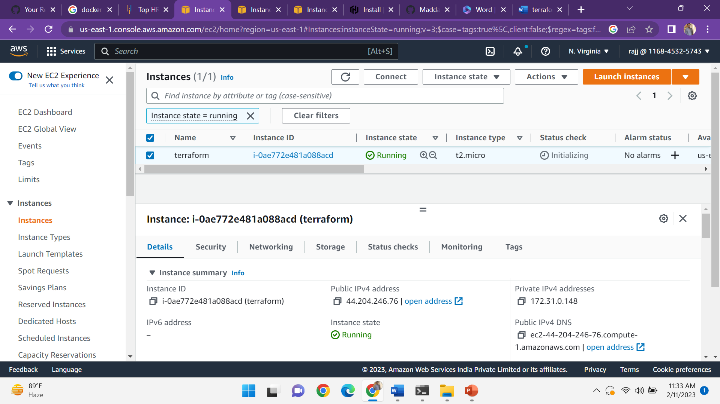

And after connect the instance to the terminal by using the keypair

Ssh -I “key.pem” ec2-user@public ip

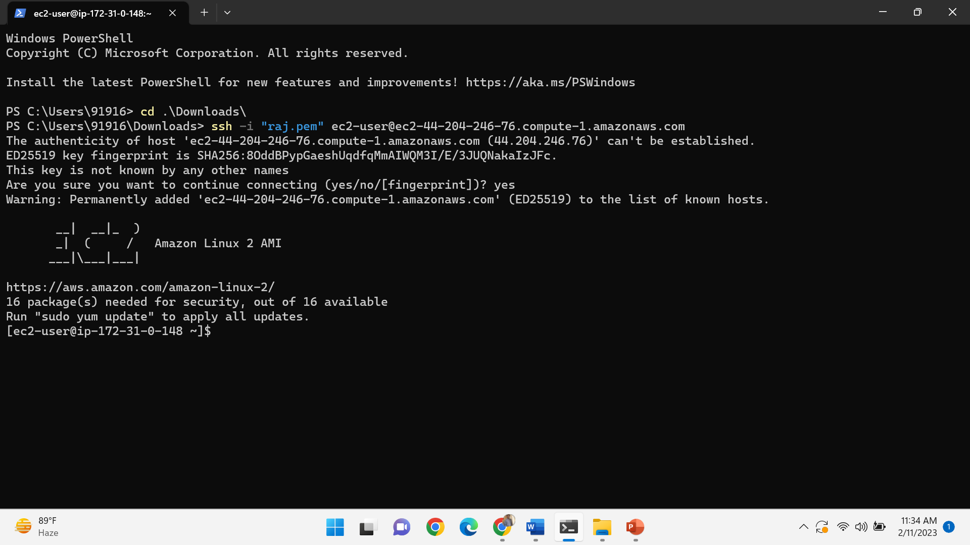

And then update the system by using the following command

Sudo yum update -y

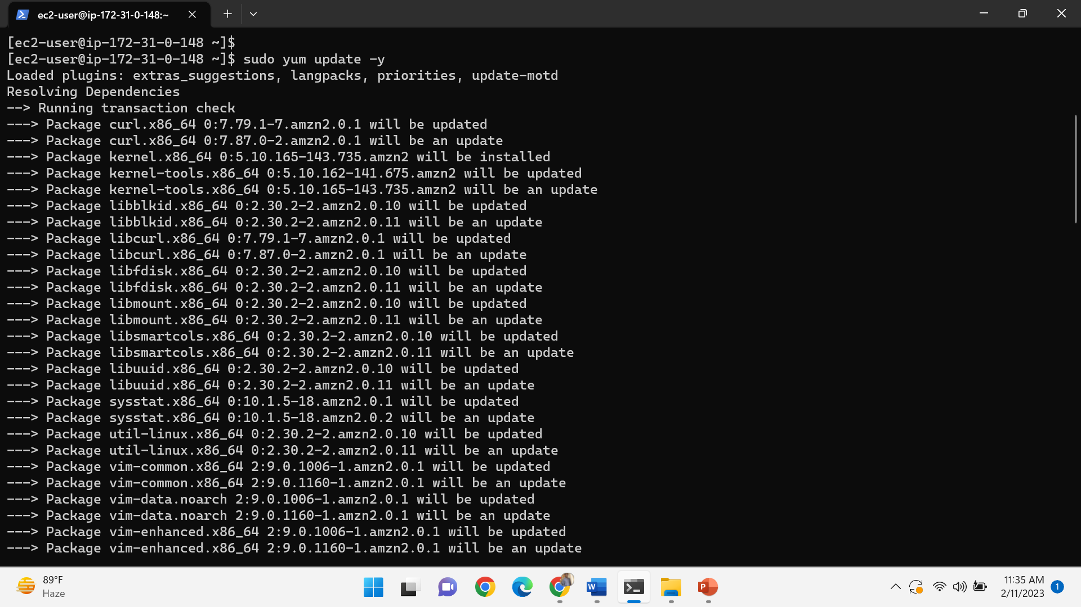

Install git by the command-sudo yum –y install git

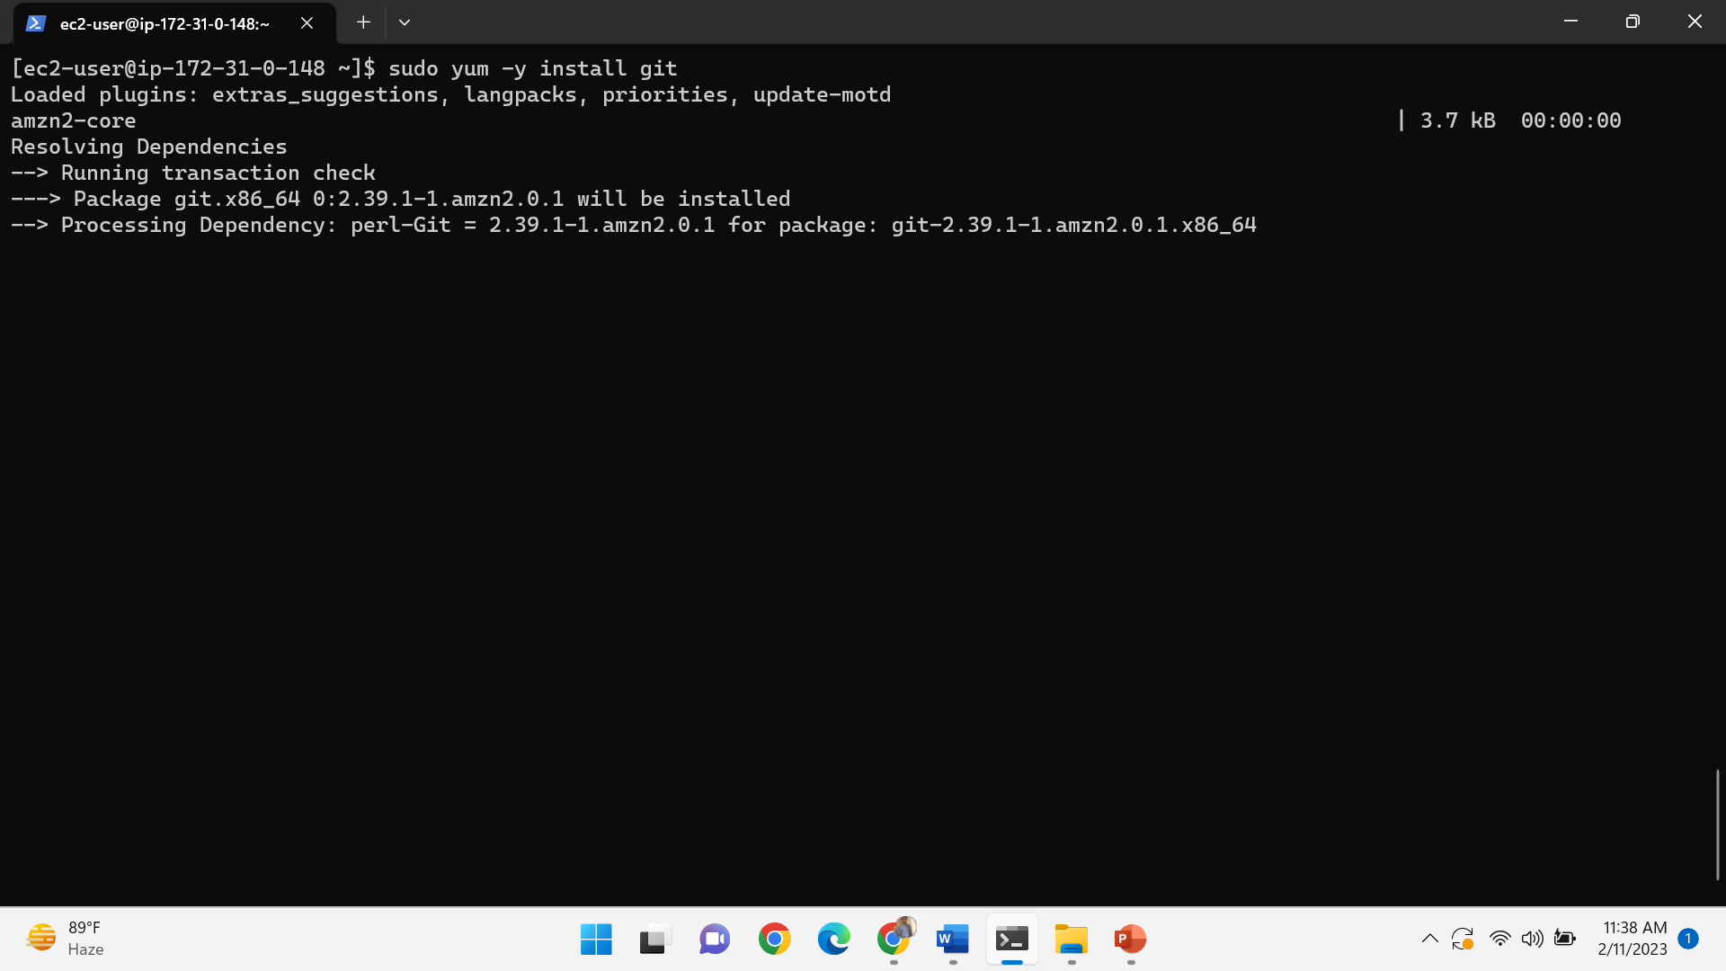

Install terraform by using the following commands

sudo yum install -y yum-utils shadow-utils

sudo yum-config-manager --add-repo https://rpm.releases.hashicorp.com/AmazonLinux/hashicorp.repo

Sudo yum –y install terraform  
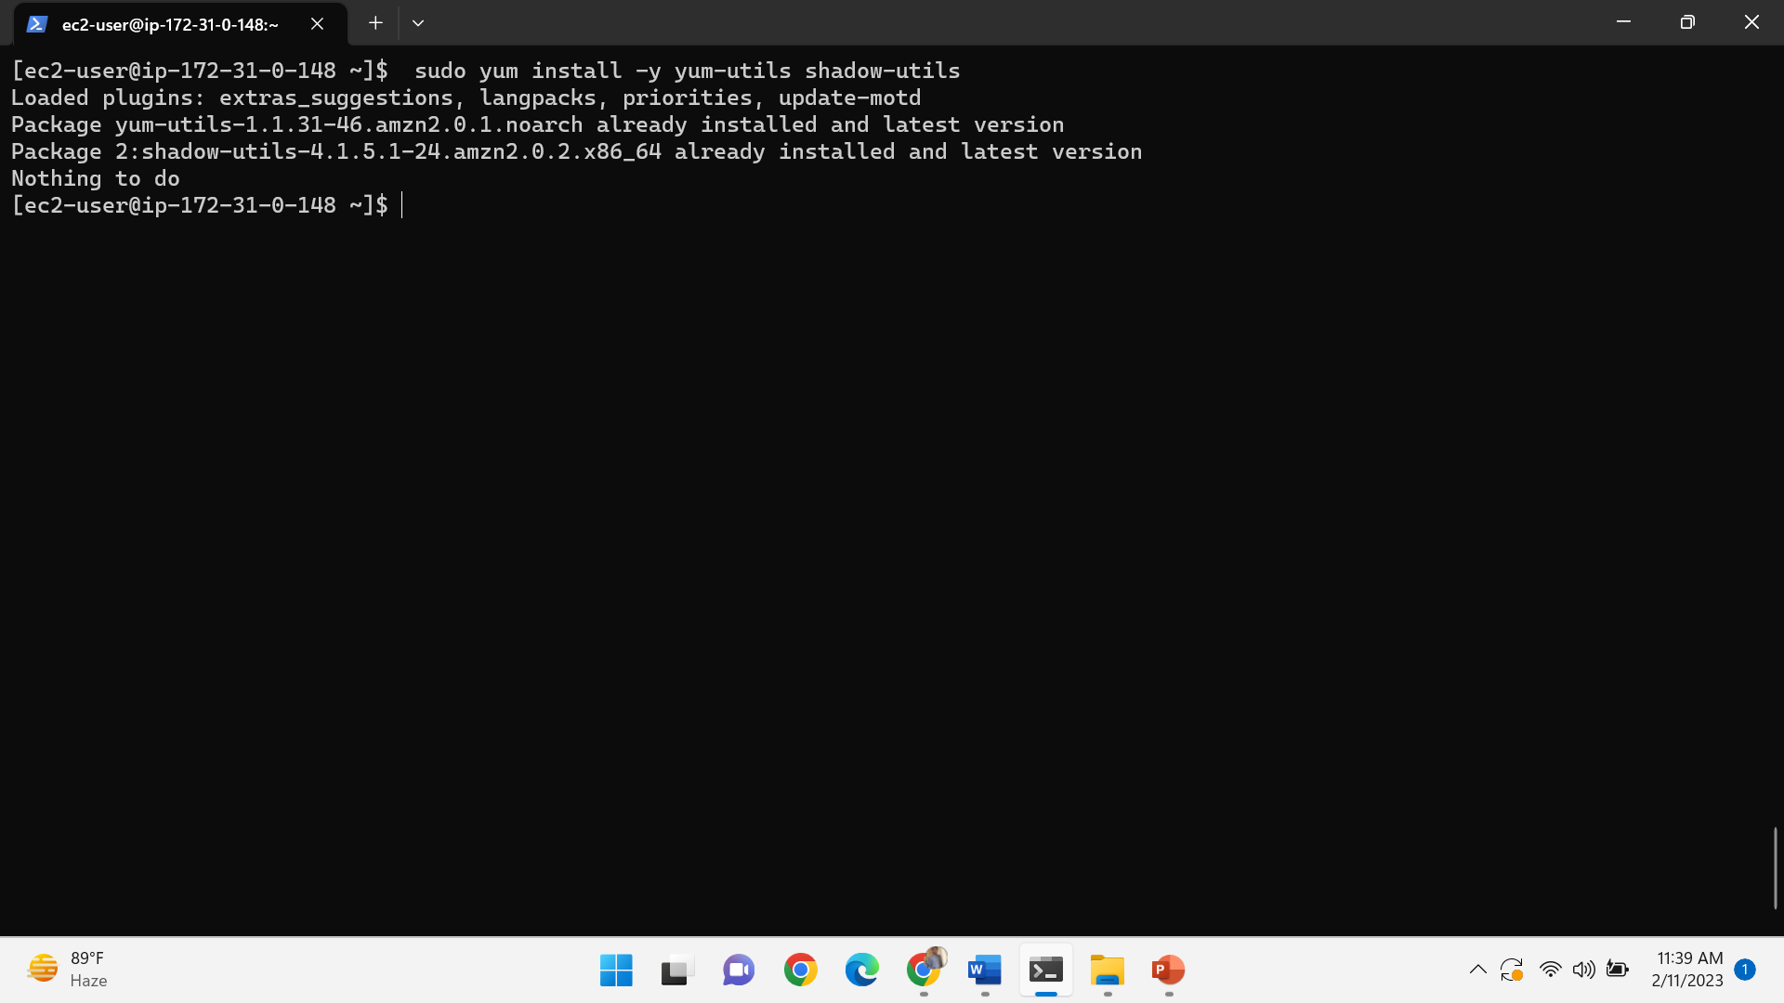

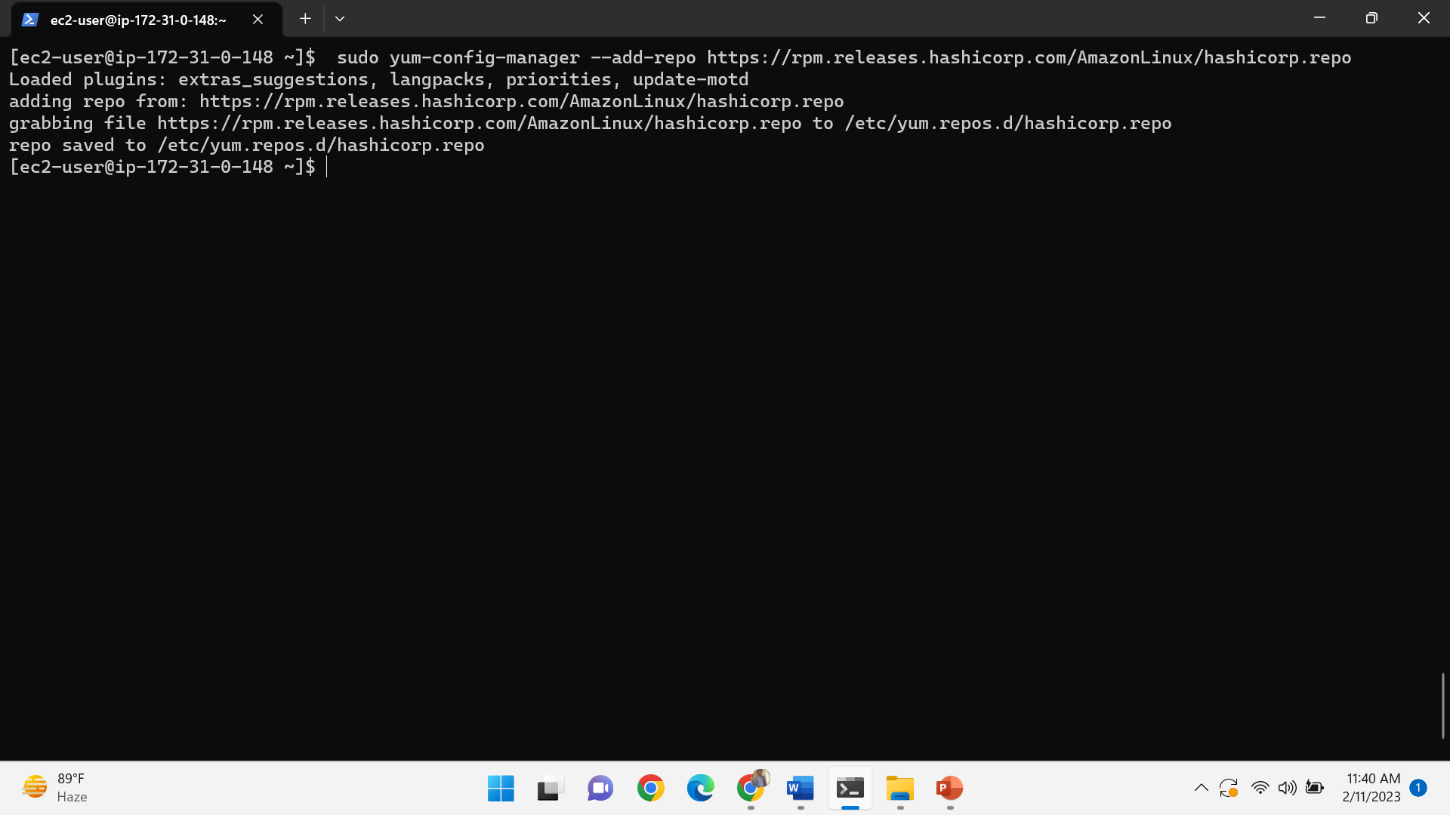

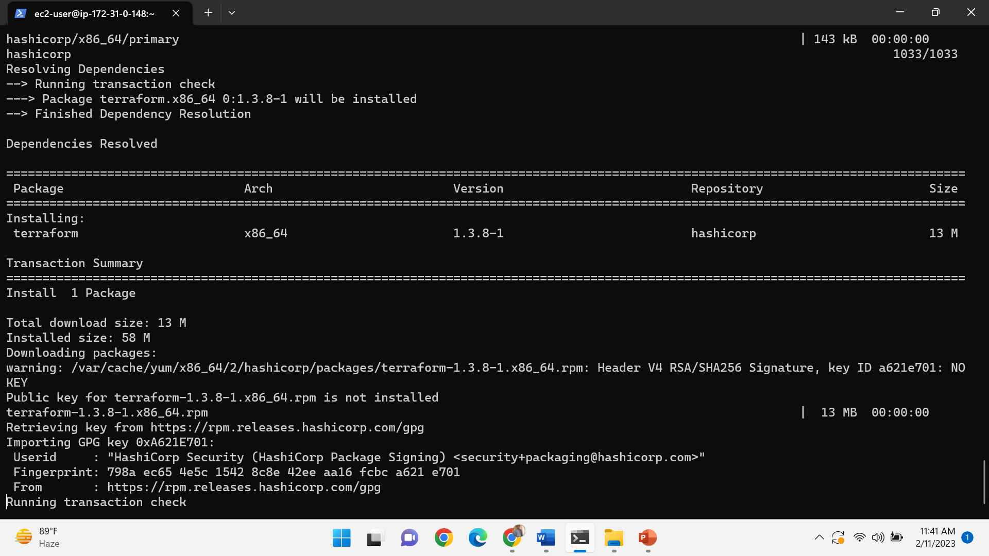

Install the jenkins through native system packages and their dependencies and run the java run environment

sudo wget -O /etc/yum.repos.d/jenkins.repo https://pkg.jenkins.io/redhat-stable/jenkins.repo

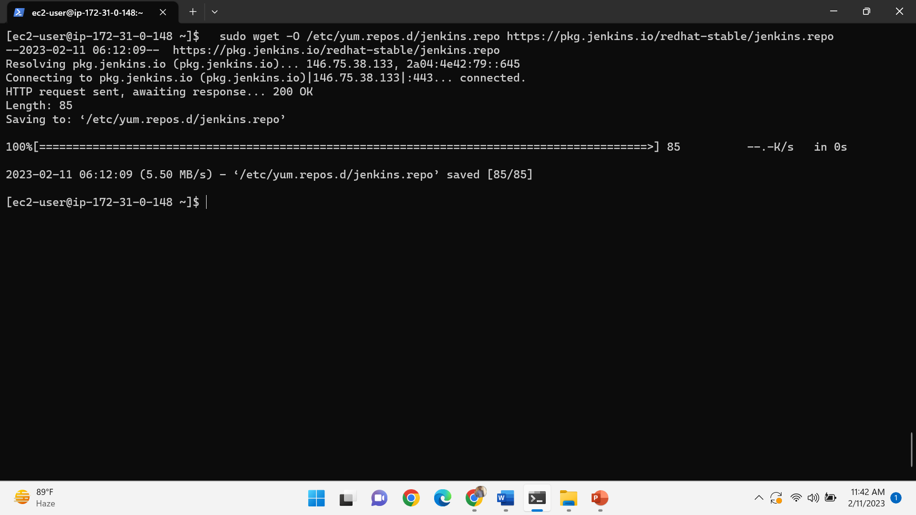

sudo rpm --import https://pkg.jenkins.io/redhat-stable/jenkins.io.key

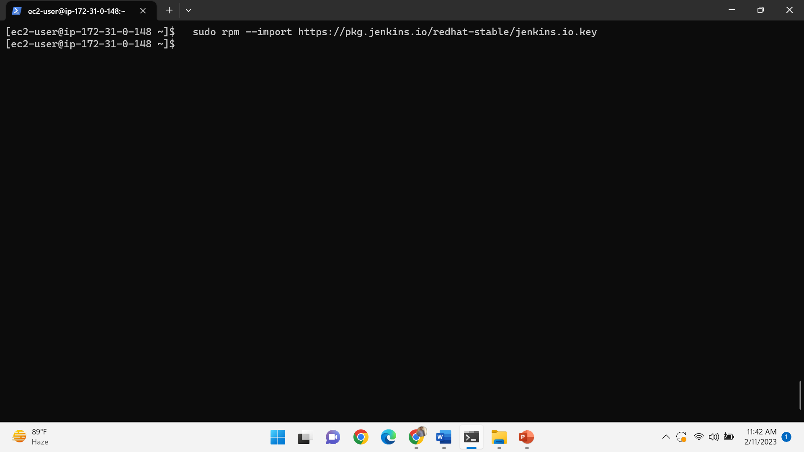

Install java by using the following command-

Sudo amazon-linux-extras install java-openjdk11

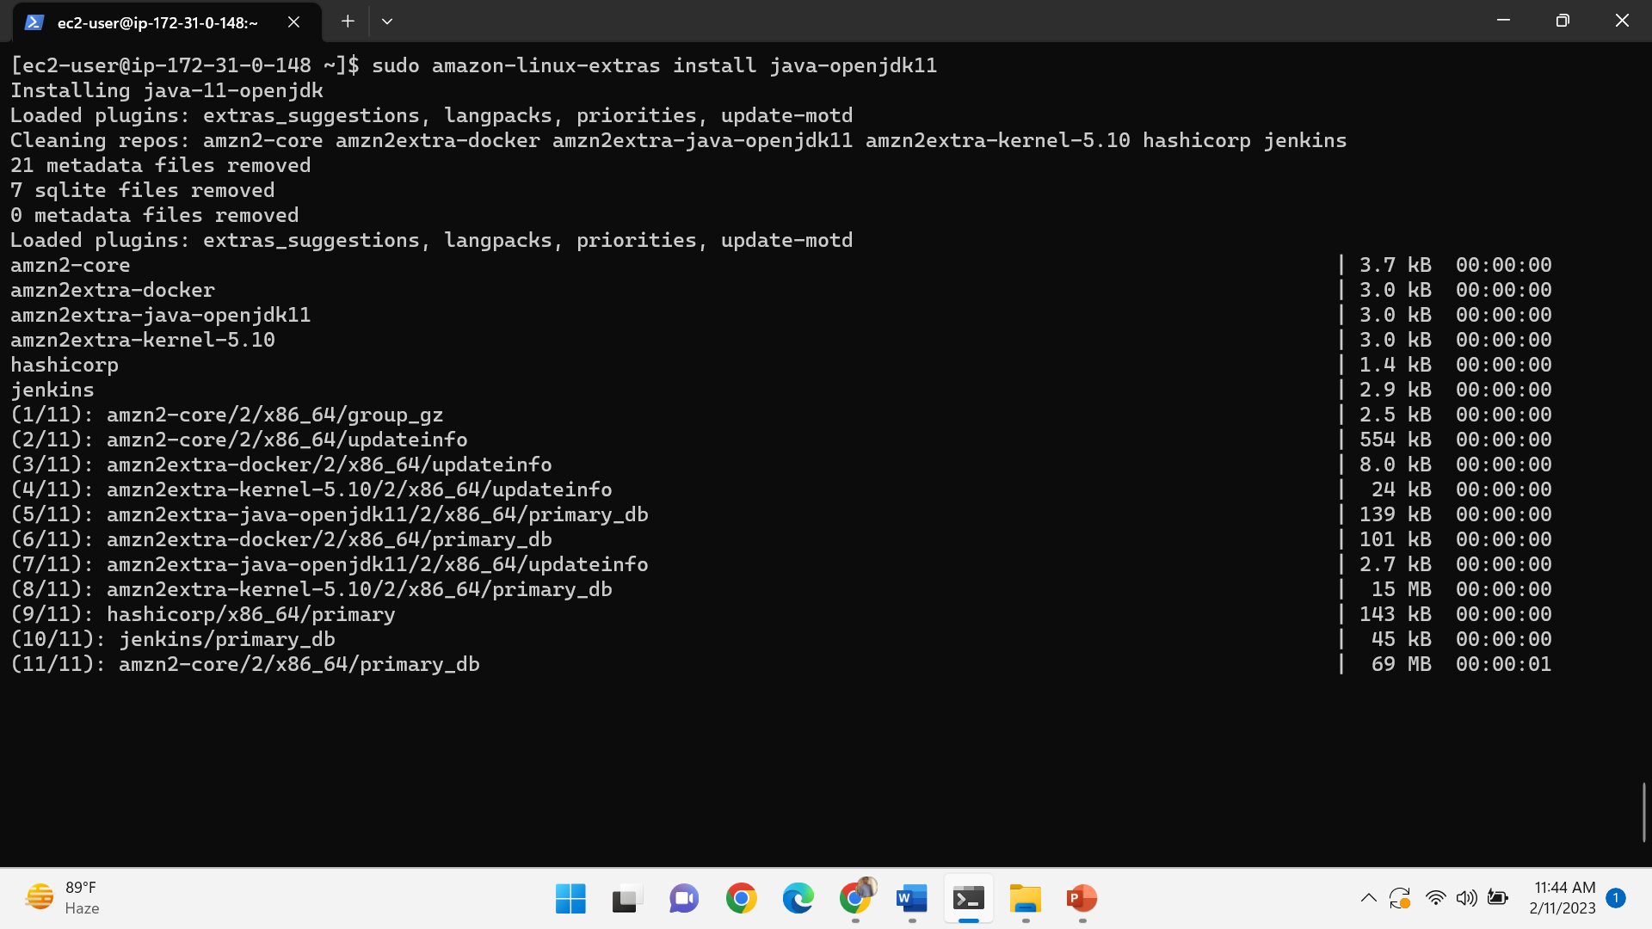

Install jenkins by using the following command

Sudo yum –y install jenkins

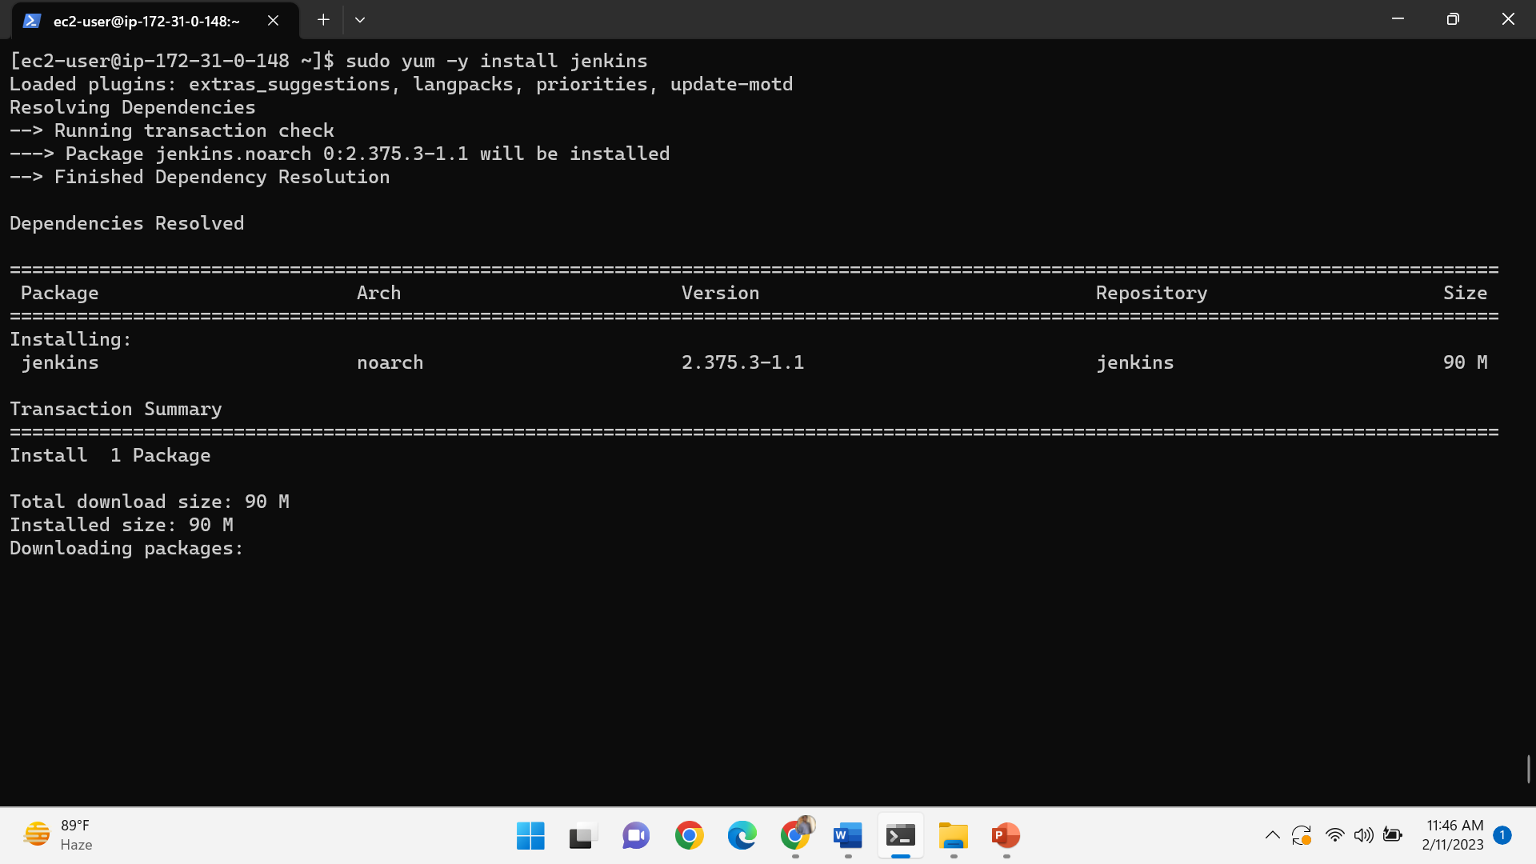

And start the jenkins-sudo systemctl start jenkins

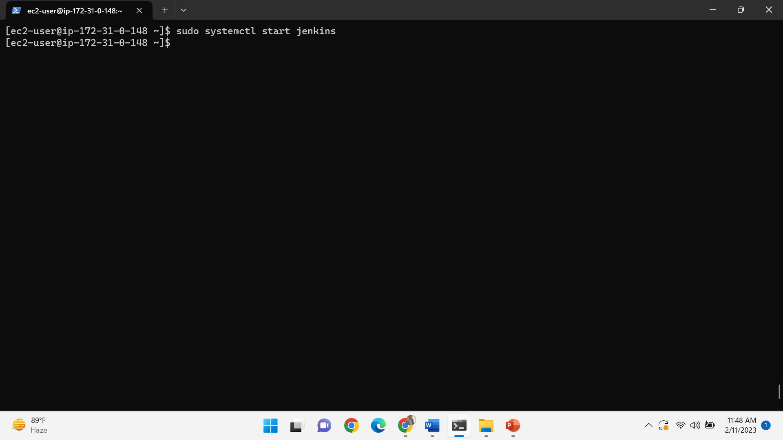

Copy the public ip adress and paste in the browser by giving the port 8080 <publicip>:8080

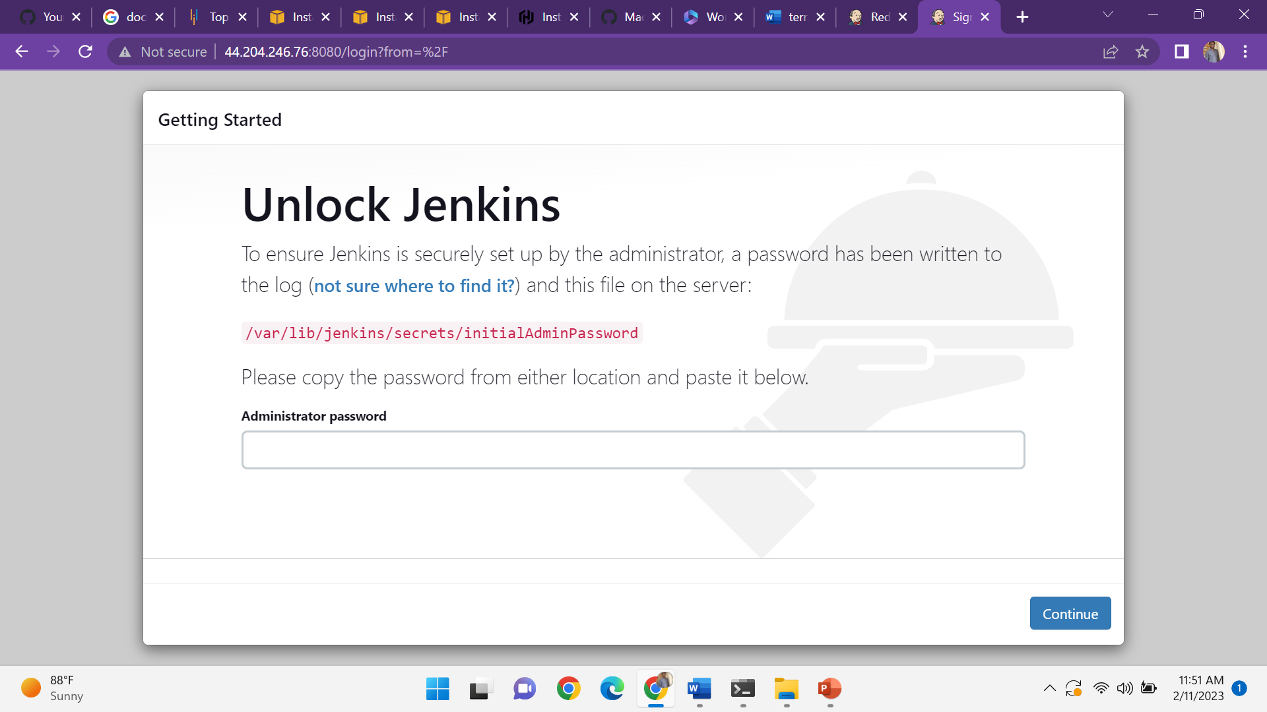

Enable the jenkins-sudo systemctl enable jenkins

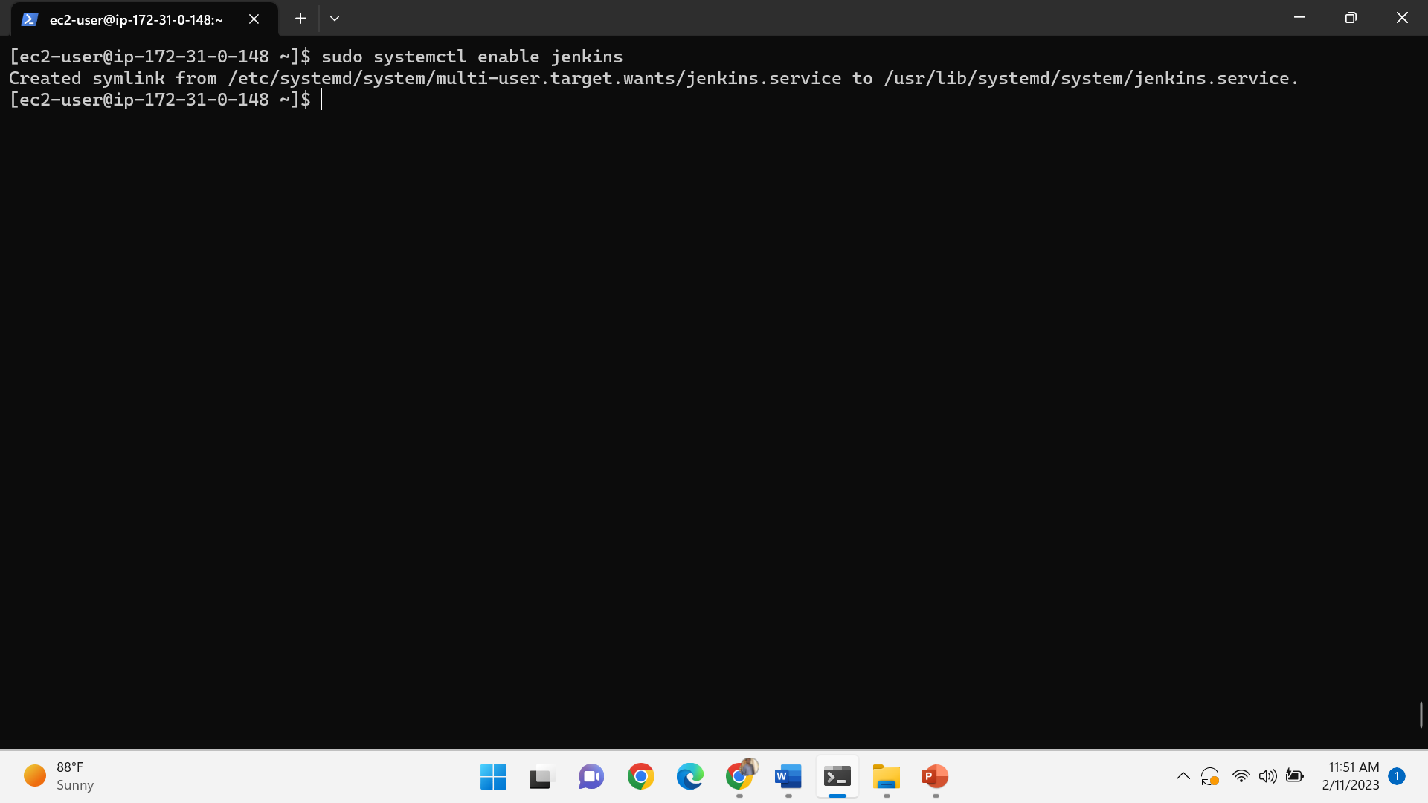

Give the command sudo cat /var/lib/jenkins/secrets/initialAdminPassword

It gives the administration password

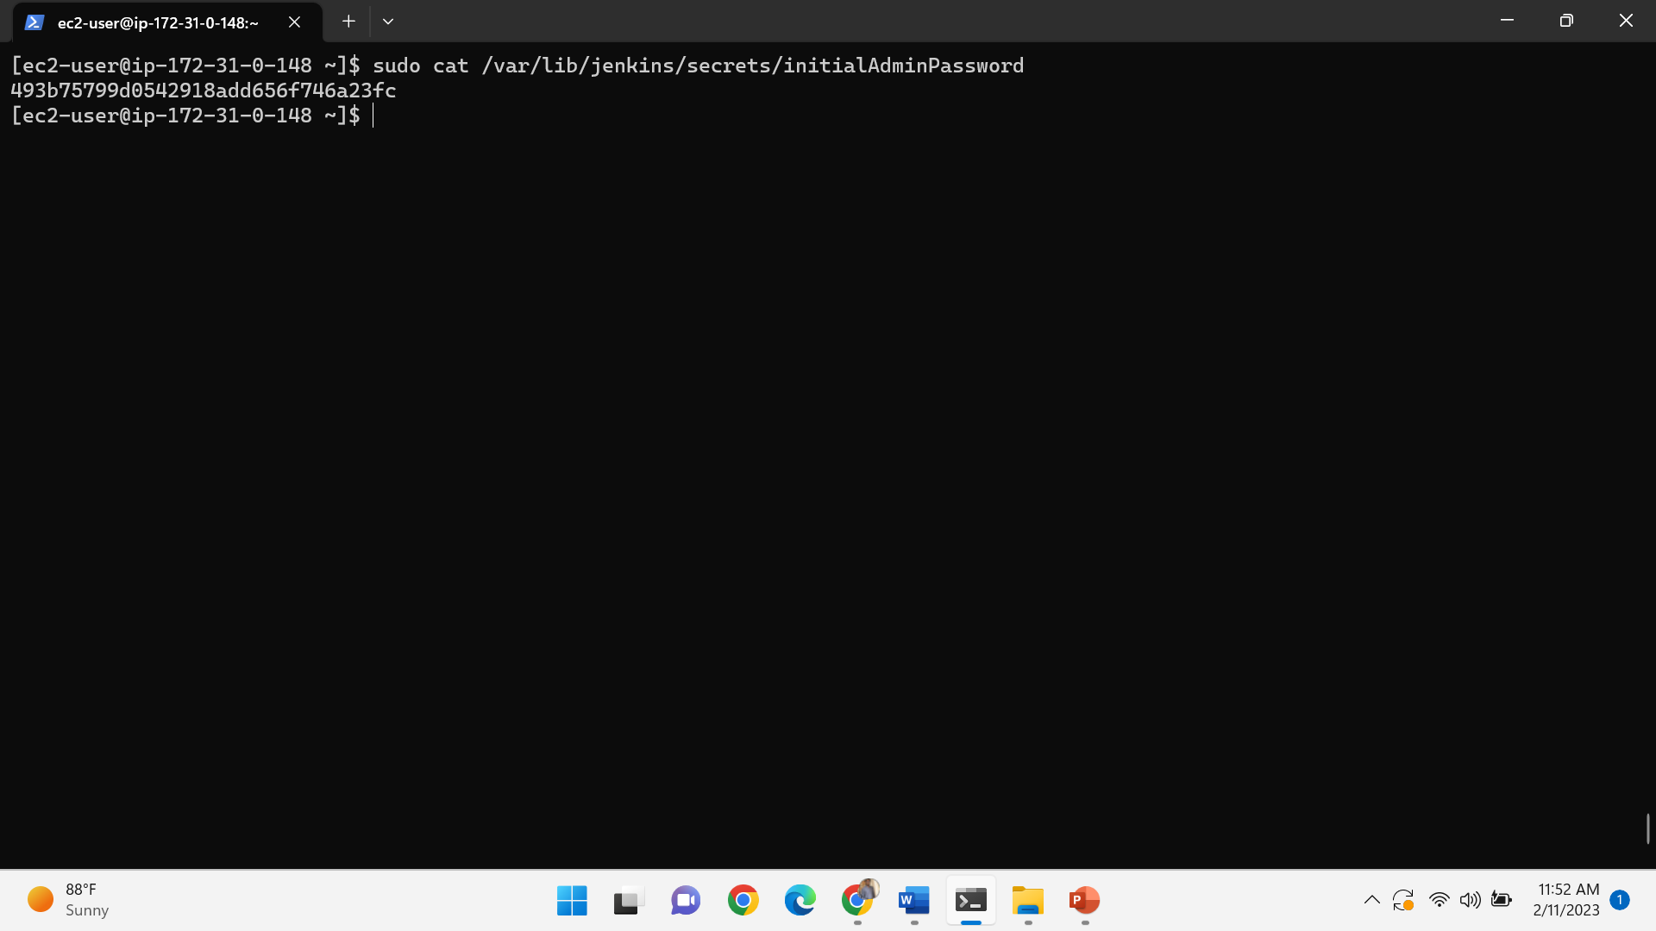

Paste the password in administration password and then click on ok

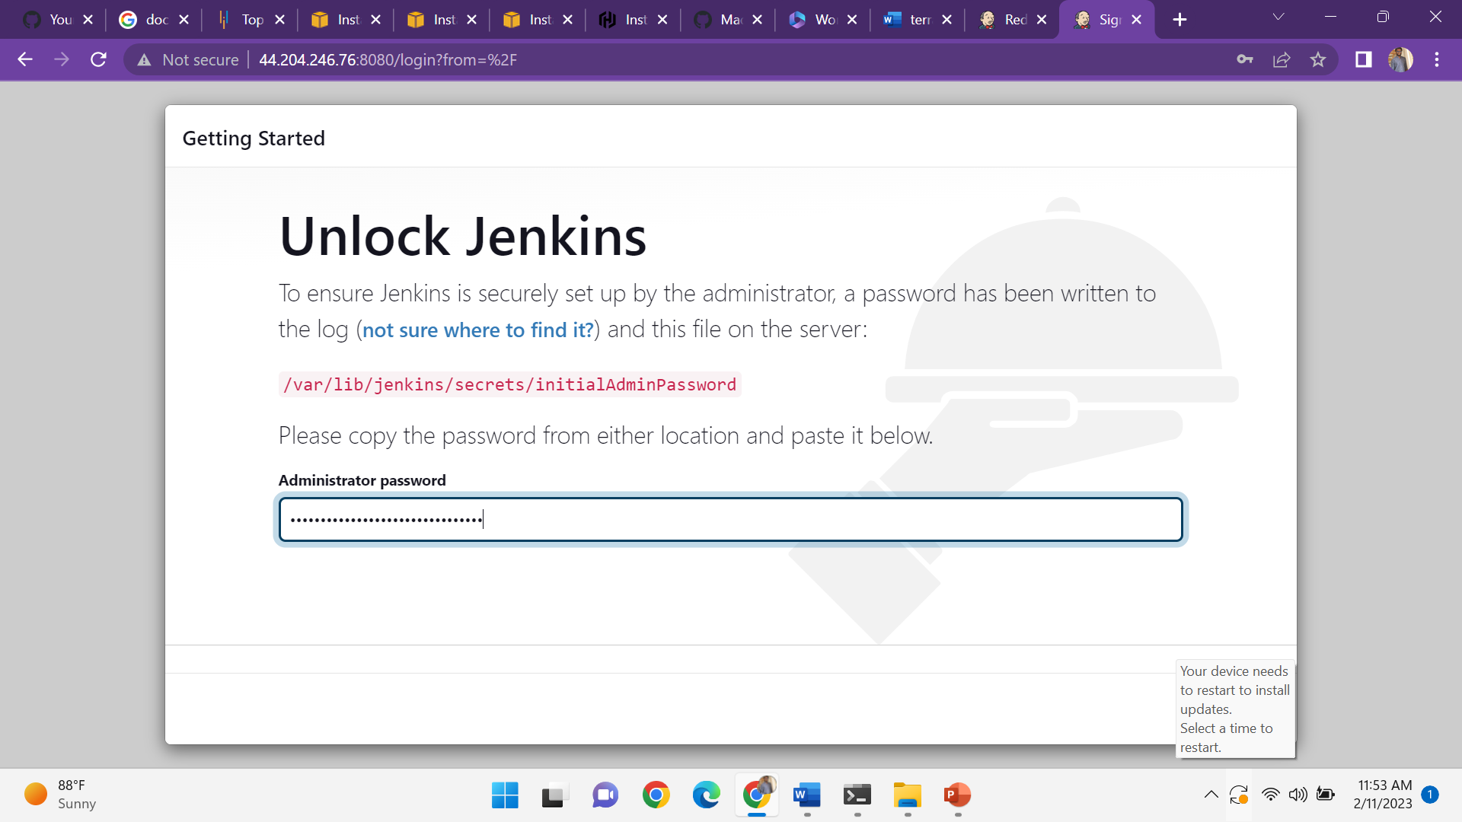

Jenkins getting started click on the install suggested plugins

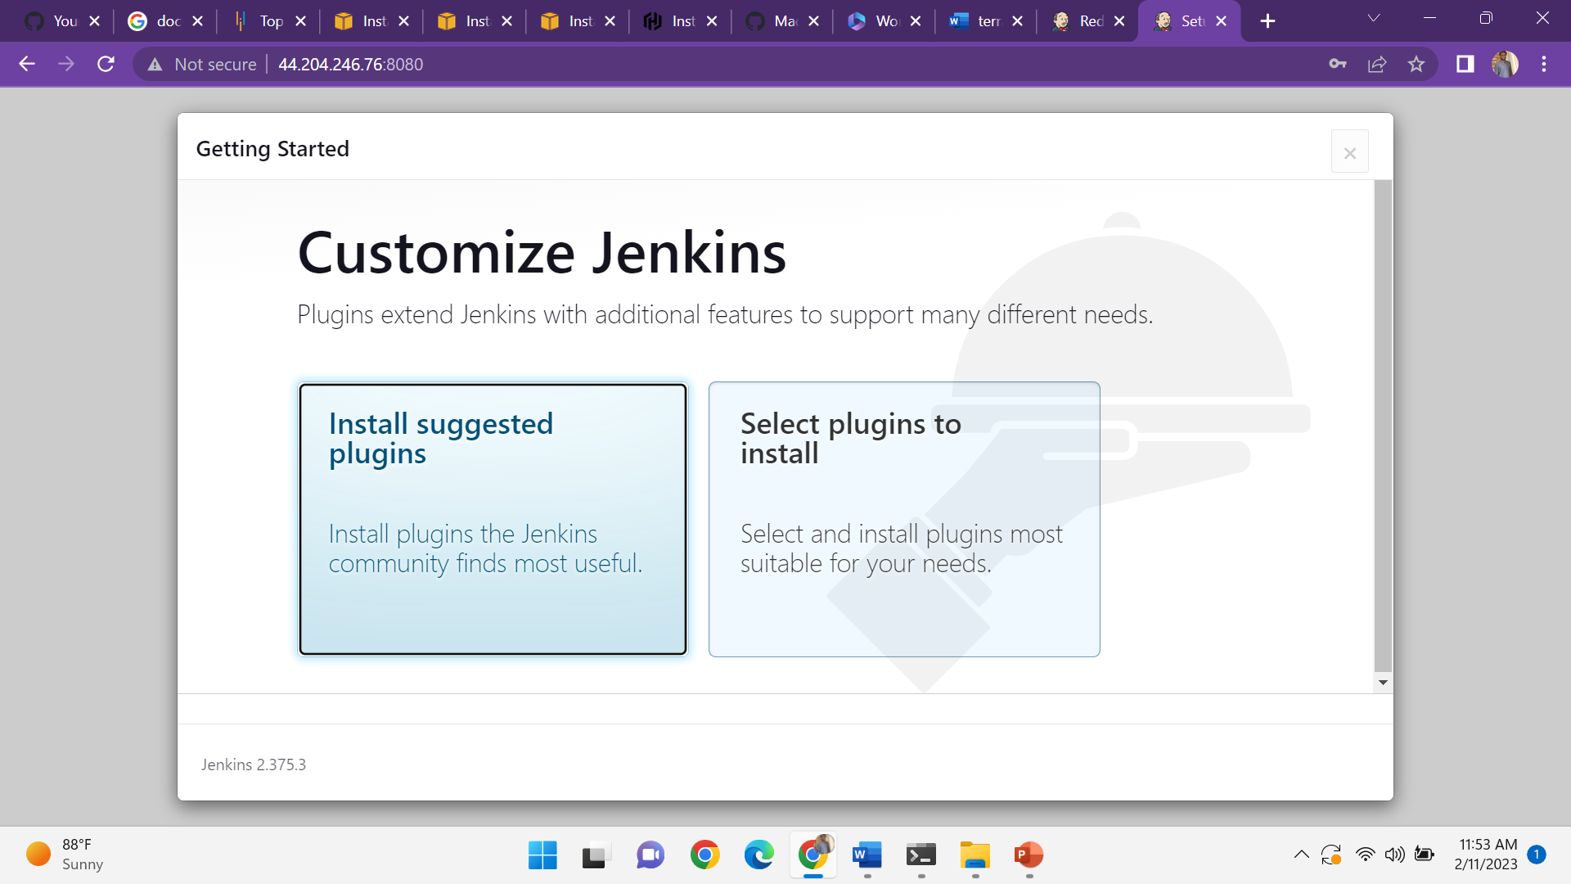

Installing the plugins

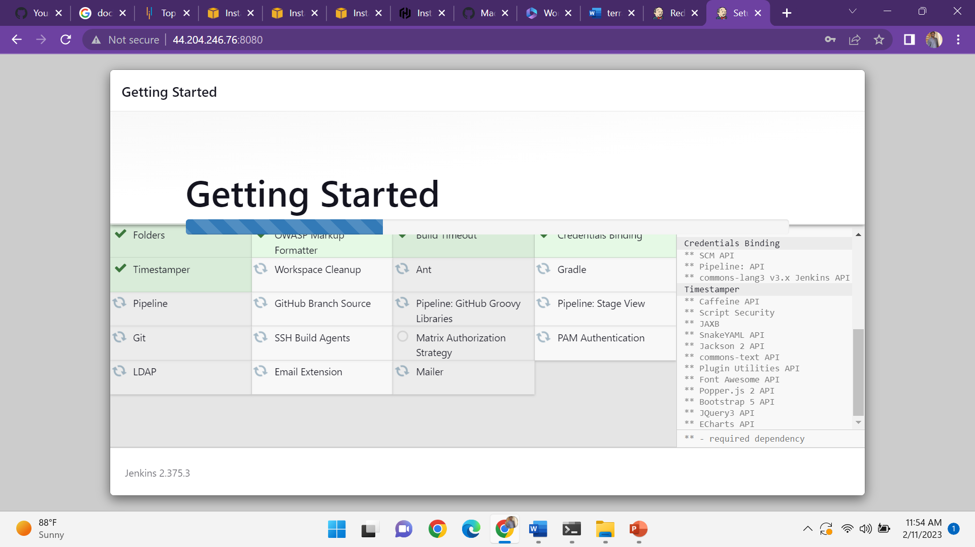

Create a first admin user give the username password and email of the user

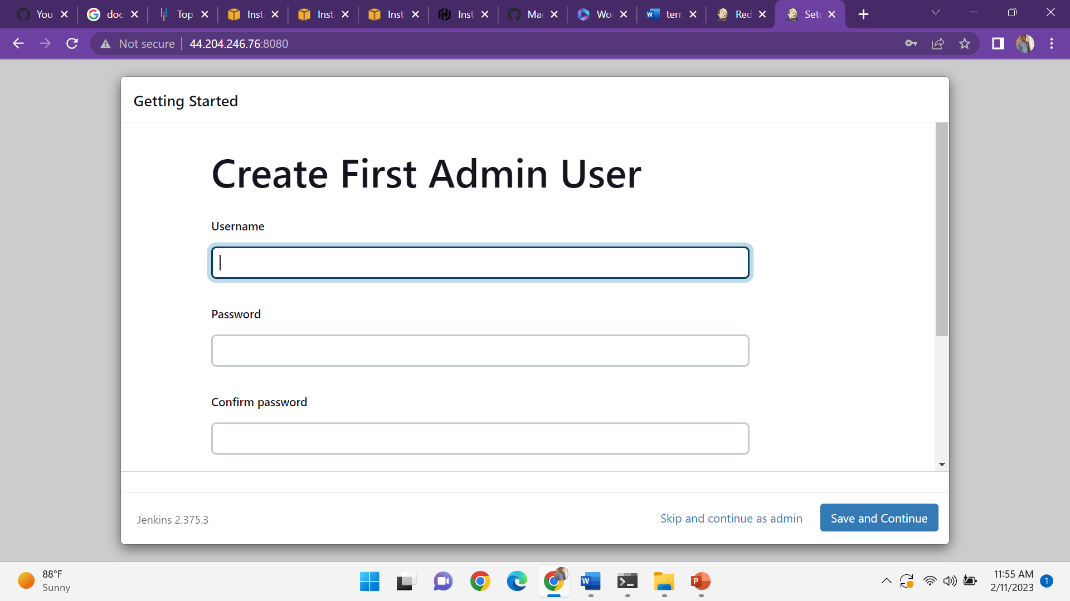

Jenkins is ready to use-click on start using jenkins

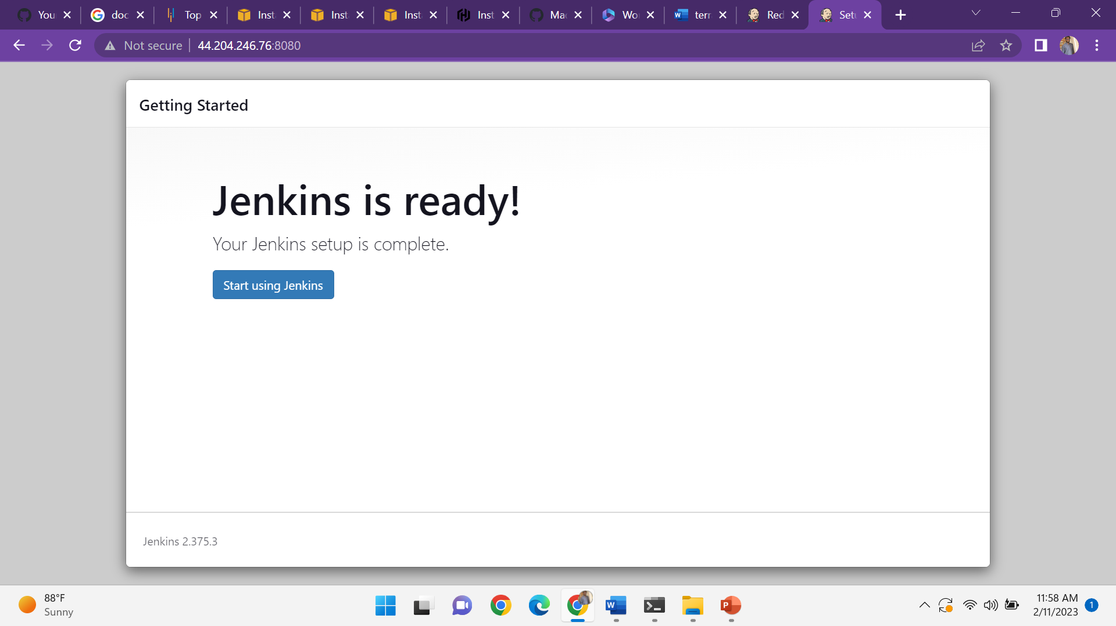

It shows the jenkins dashboard click on the new item

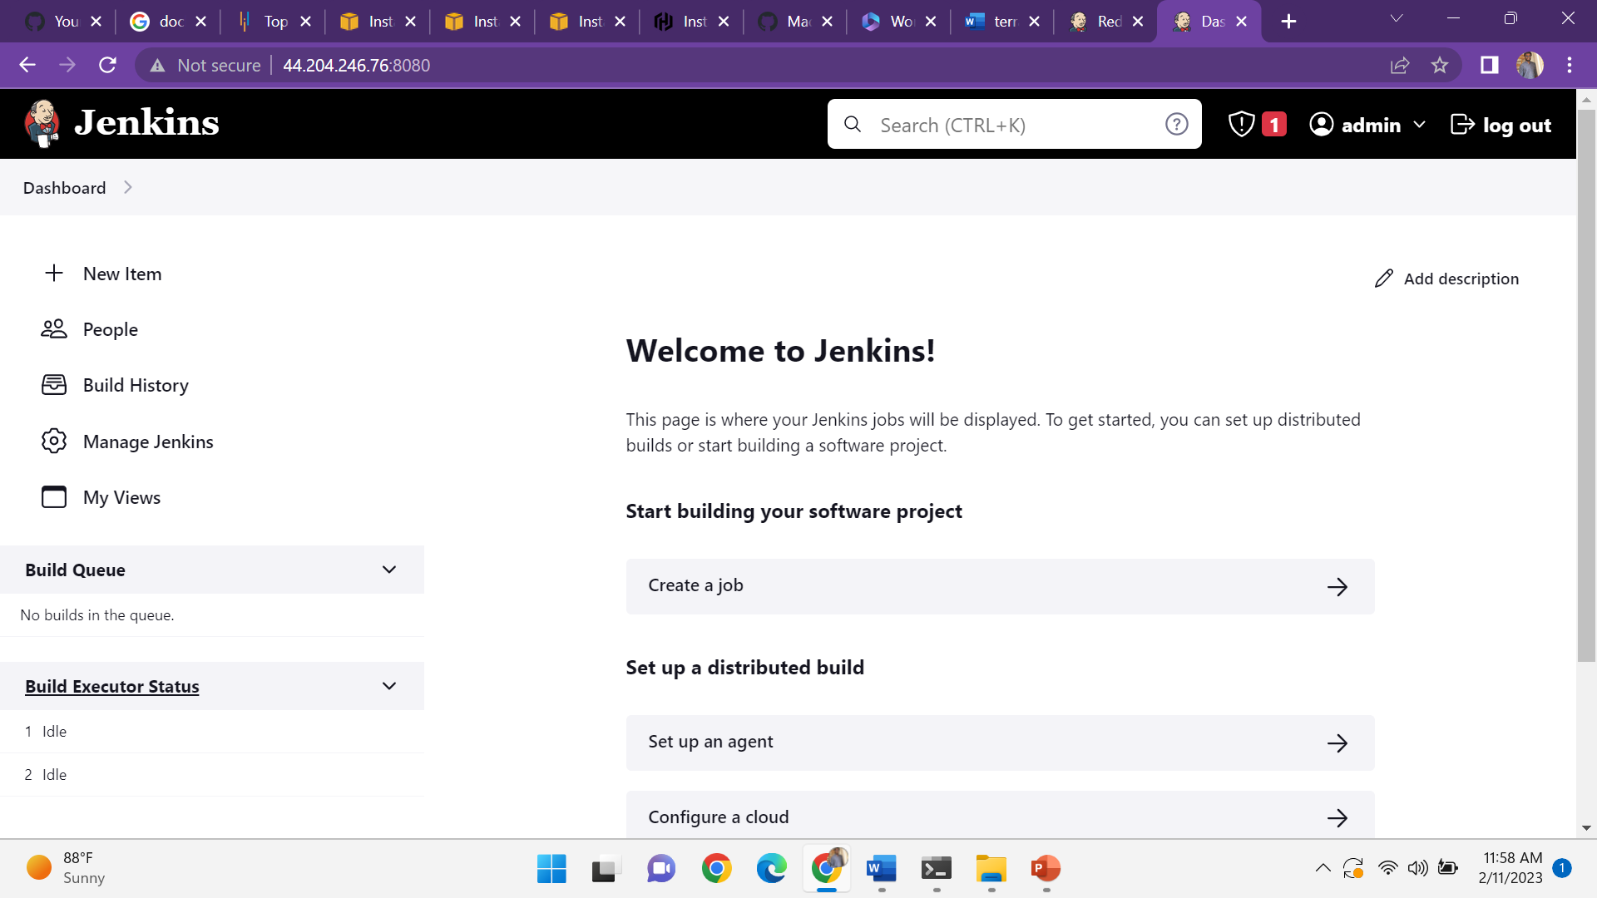

Give the item name and click on freestyle project

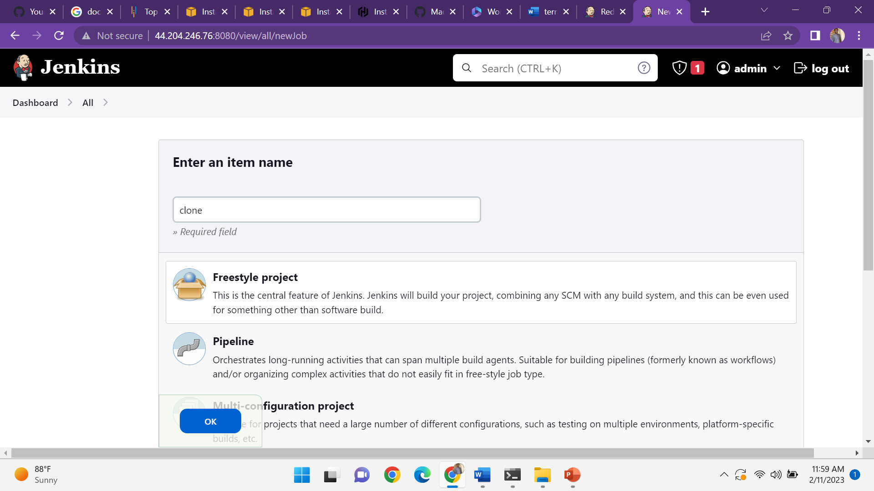

Clone the code from git and copy the url & click on save and click on console output

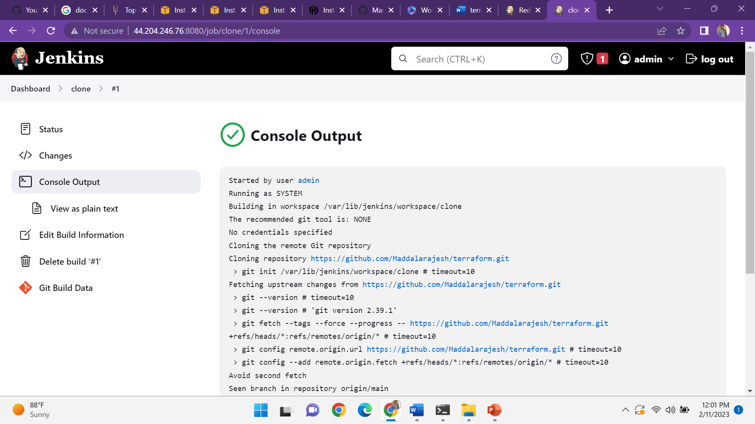

Enter the item name click on the freestyle project and copy from clone

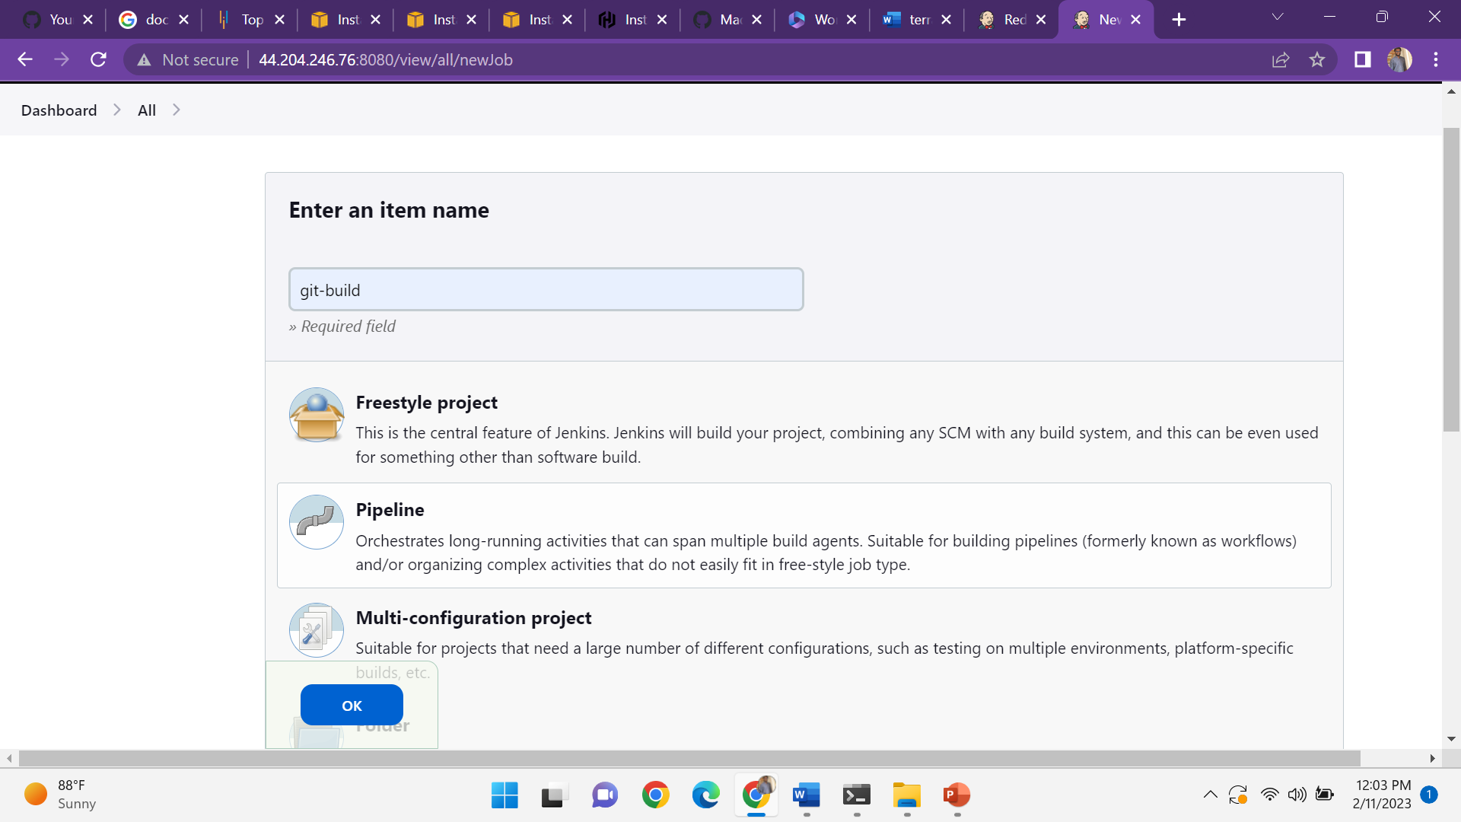

Give the description

g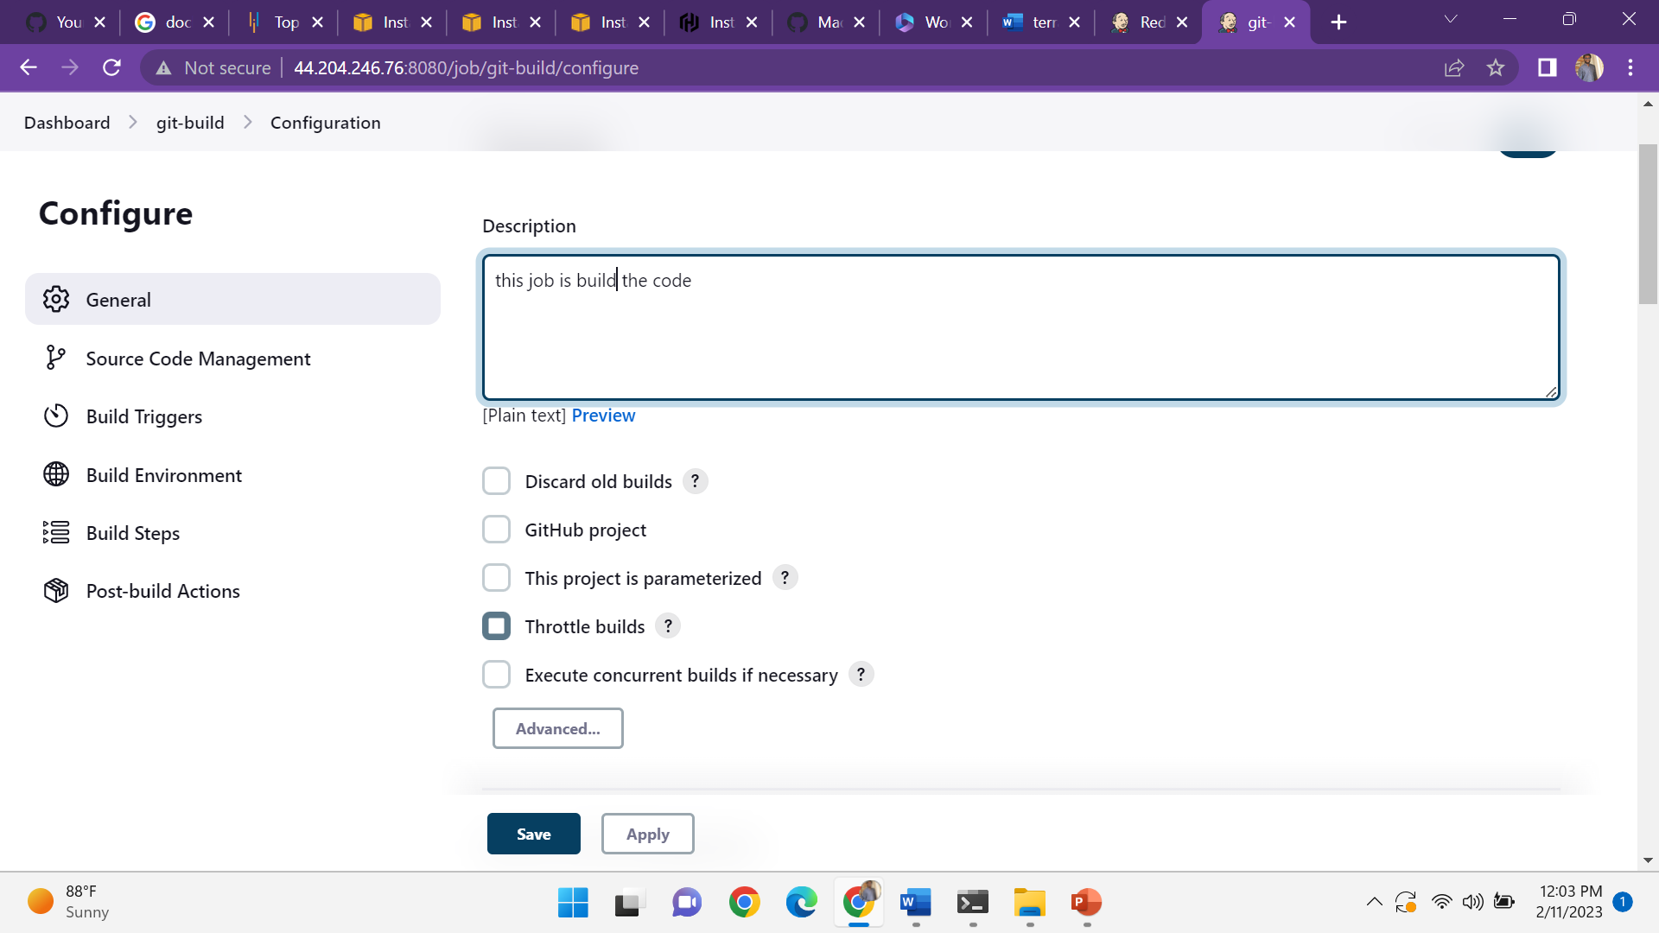

Go to the build steps action click on the execute shell

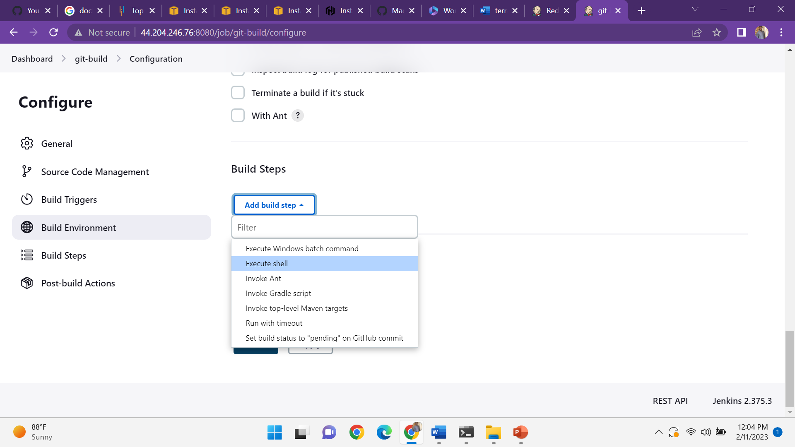

Give the commands-terraform init

Terraform apply –auto--approve

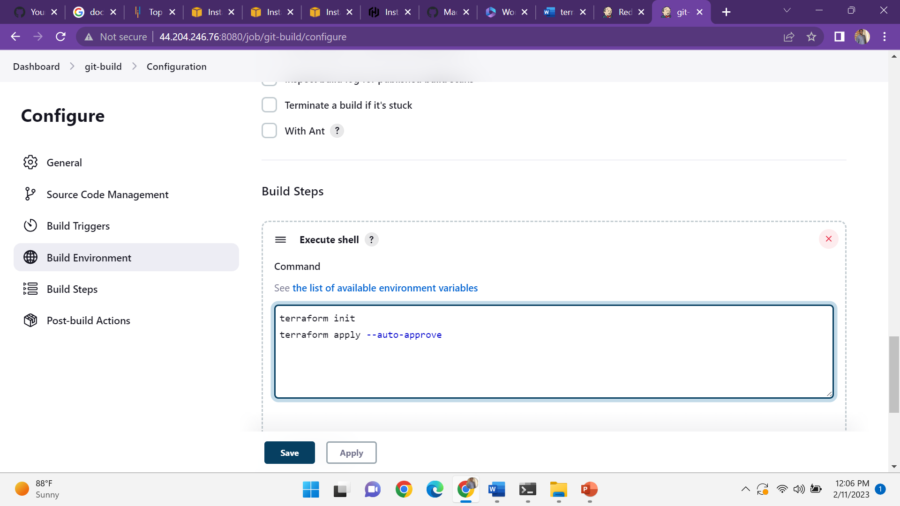

Click on the build now

